**ScotPHO Online Profiles Quick Reference Guide**

## **Landing page**

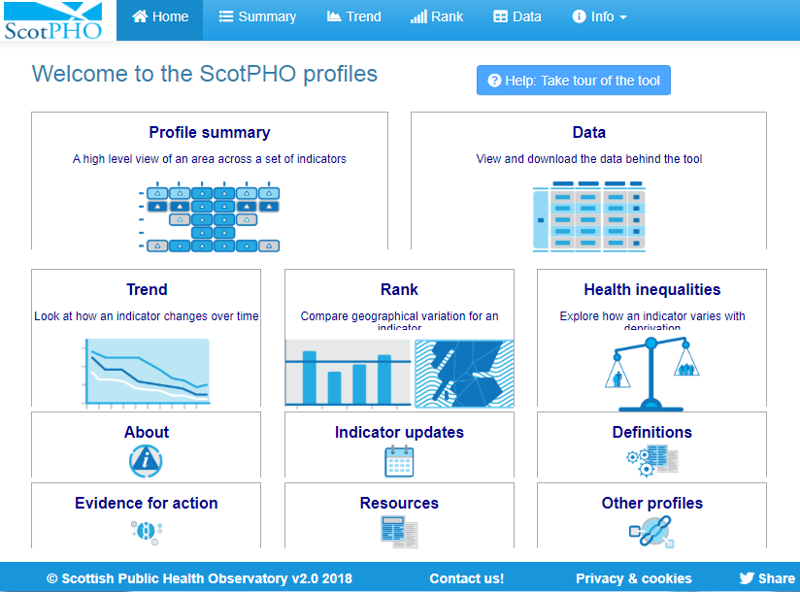**The tool can be accessed through the ScotPHO website  
 or via the link below:**

**Navigation  
strip**

[**https://scotland.shinyapps.io/ScotPHO_profiles_tool/**](https://scotland.shinyapps.io/ScotPHO_profiles_tool/)

**When you start the profiles tool for the first time you will see a landing page.**

The tool provides two different routes to navigate around the app:

The **navigation buttons** on the landing page or the **navigation strip** along the top.

The **home button** (top left) will always take you back to the landing page.



## **profile SUMMARY**

Over 200 indicators are available within our profiles tool. ScotPHO have created a number of profiles which include a selection of indicators related to a particular theme (e.g. Health and wellbeing, Children & young people, Drugs etc).

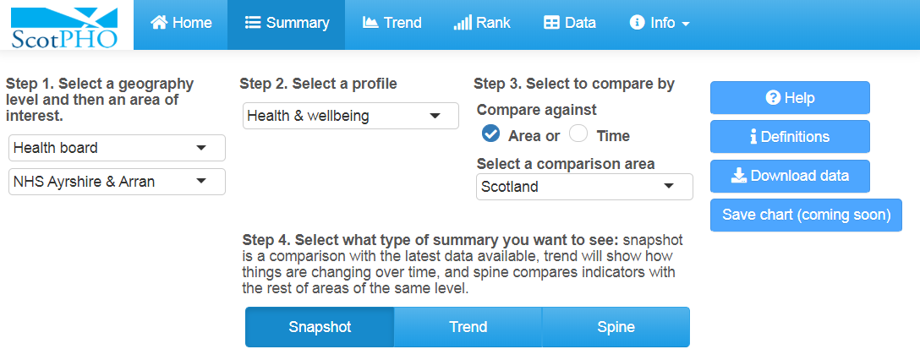The **profile summary** provides an overview for a single ScotPHO profile. Drop-down menus at the top let you choose a profile set, a type of geography and a specific area. You can also choose to compare indicator changes with another area or a baseline year.

Get help or download the data using the blue buttons on the right.

Choose from 3 different types of summary charts

* Snapshot
* Trend
* Spine

## **Summary: Snapshot**

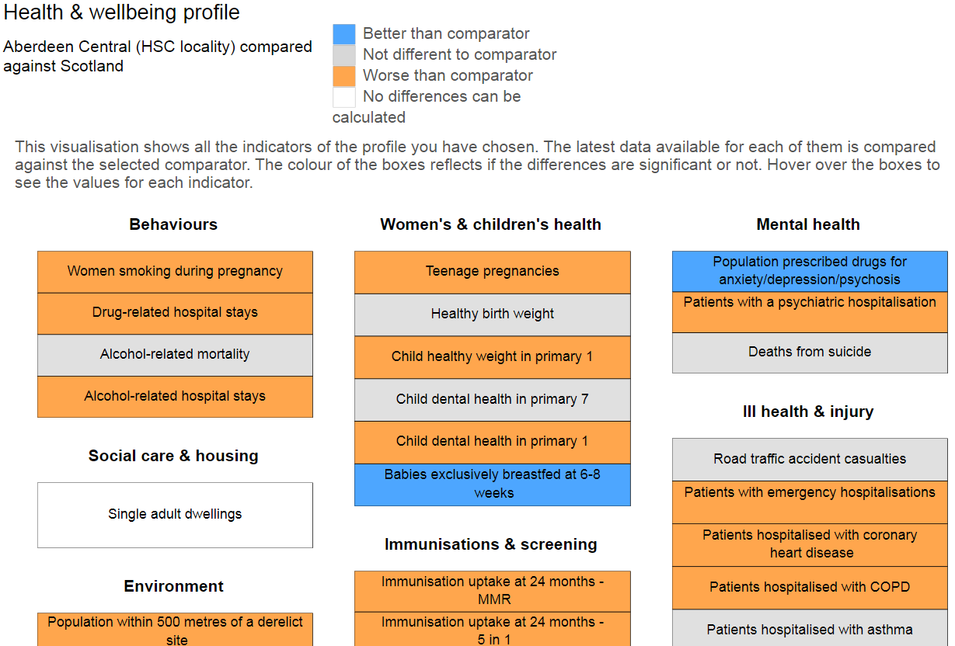Indicators within each profile contains are grouped into several topic areas. The colour of the boxes signifies if the selected area is better, worse or similar to the comparator. We use statistical significance testing to assess if measures are different from a comparator. Hover over the boxes to see the values for each indicator.

Drop-down menus on the left let you choose a profile set, a type of geography and a specific area. You can compare indicator changes with another area or a baseline year. You can download the data or the chart image using the blue buttons on the left.

**Use this chart** to quickly see which domains within a profile may be performing better or worse in a specific area than your chosen comparator.

**This chart might help** to identify which topic areas may warrant closer inspection using other charts in the tool such as the heatmap or barcode chart.

## **Summary: Trend**

The **trend summary** provides a view over time for indicators within a profile.

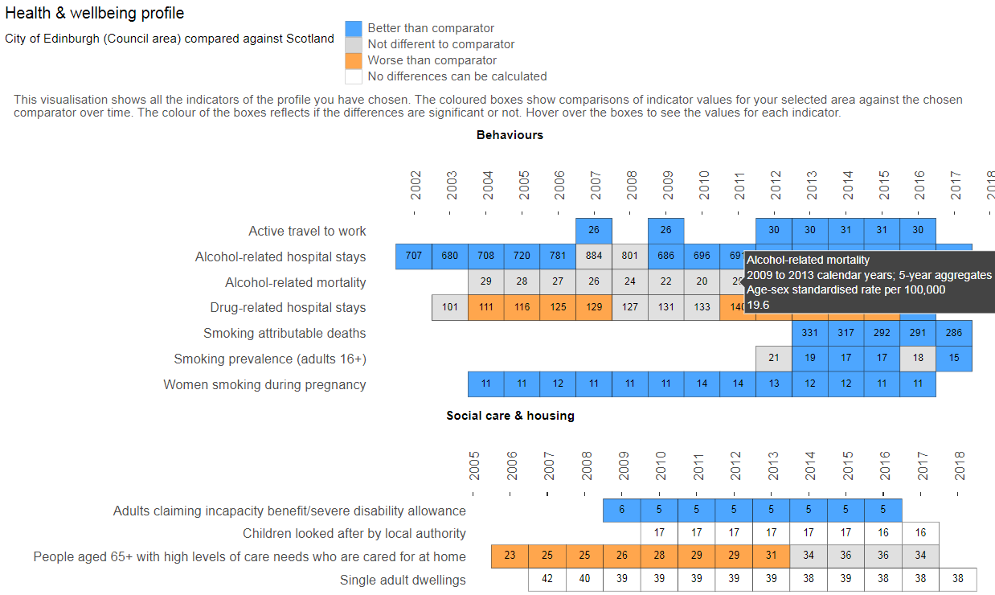Drop-down menus at the top let you choose a geography type, a profile, the specific area you are interested in and a reference area to compare with. You can also compare changes in indicators in relation to a baseline year.

**Use the trend summary** to assess if indicators within a profile area have been significantly better or worse over time compared with the reference population you have selected. The “time” option at the top also lets you see whether there have been significant changes in an indicator since a specific baseline year.

**The trend summary might help** to identify indicators where an area is comparatively better than a reference population or identify significant changes in an indicator since a baseline year.

## **Summary: Spine**

The **barcode** chart shows the indicator values for all areas in Scotland, highlighting the area you have selected and a reference area. It shows the relative performance for selected indicators at a specific time point.

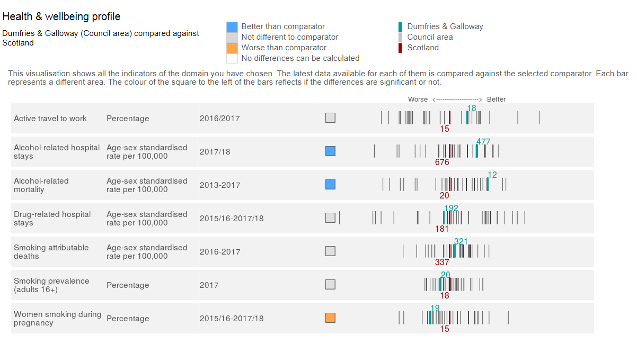Drop-down menus let you choose a profile and domain, a type of geography, the specific area you are interested in and a reference area to compare with. Blue buttons on the left allow you to download the data or chart image.

Coloured squares show whether the difference between the area you have selected and the reference area is statistically significant.

**Use this chart** as a quick guide to the relative performance of one area compared to other areas in Scotland for a set of indicators.

**This chart might help** to identify indicators where the area of interest is substantially different from the reference area. It can also identify indicators where the variation across the different geographical regions is small or large.

## **DATA**

All of the chart tabs have buttons that allow data to be downloaded for the particular chart being viewed.  
You can use the **Data** tab to view or download larger sections of data.

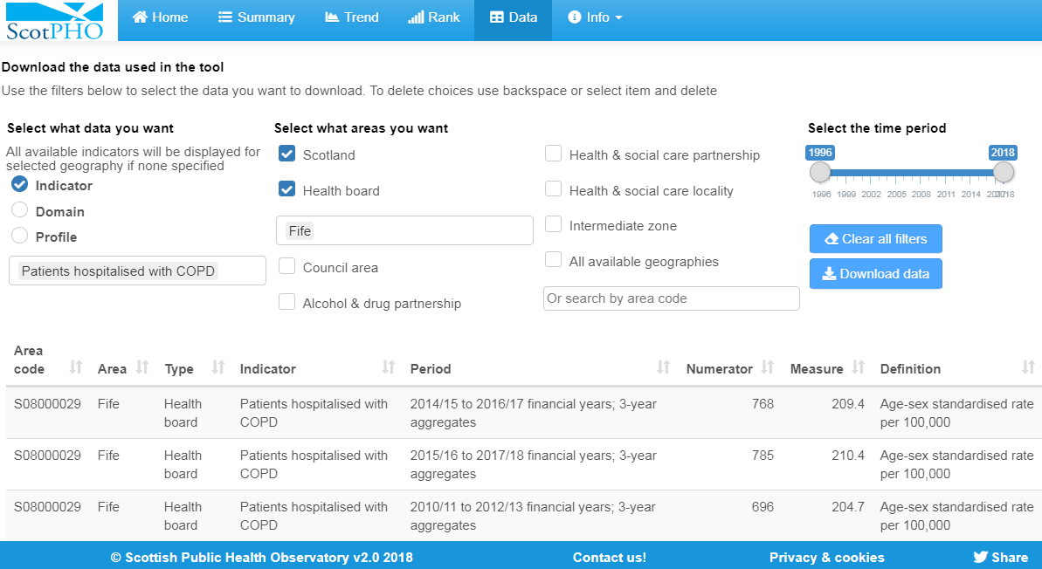Start on the left by choosing either a single indicator or all indicators within a specific domain or profile. To select your specific indicator, domain or profile simply click and select or start to type in the box. Multiple selections are allowed.

To further filter this data, select from the geography menu your geography type of interest by ticking each relevant box, which will allow you to further filter for specific areas, or choose ‘All available geographies’ to display all areas.

Finally, you can select a time period using the slider control on the right and using the blue download button, save your data selection as a comma separated value (csv) file, readable in MS Excel or imported into other programs.

## **TREND**

The **trend chart** shows how a single indicator has changed over time for one or more areas. By default 95% confidence intervals showing variability in the data are hidden, but can be added using the tick box on the left.

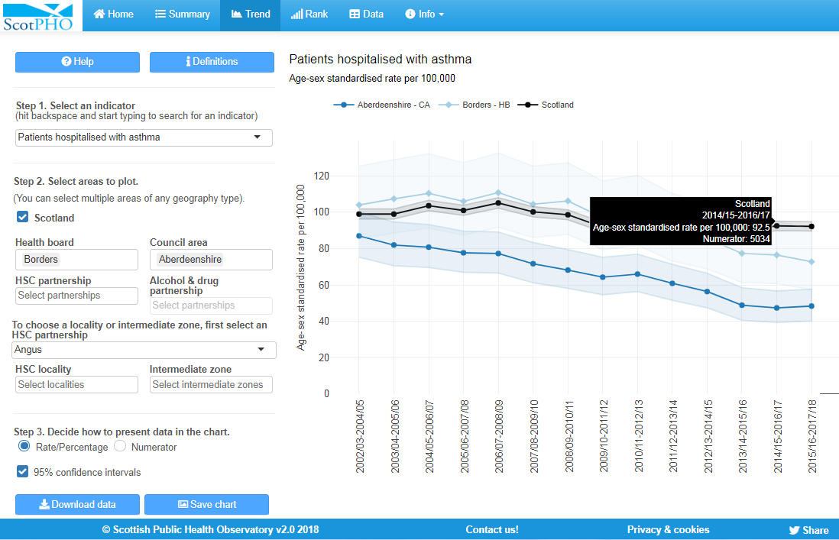Click on the indicator at the top left to see the full list of indicators to choose from. To choose an area, click in the health board, council or smaller area boxes on the left to show a list of areas to select from. If data are not available for a smaller area then it will not be possible to click in the selection box. You can select multiple areas within one selection box. To remove areas simply delete them from within the selection box. Blue buttons at the bottom allow you to download the data or chart image.

**Use this chart** to see trend and comparative information about a single indicator for several local areas.

**This chart might help** to explore if an indicator is increasing or decreasing over time and to compare trends with other areas or with Scotland as a whole.

## **RANK & Map**

The **rank chart and map** show how a single indicator compares across different geographic areas at one point in time. These charts allow comparisons between areas of the same type e.g. NHS board or local authority.

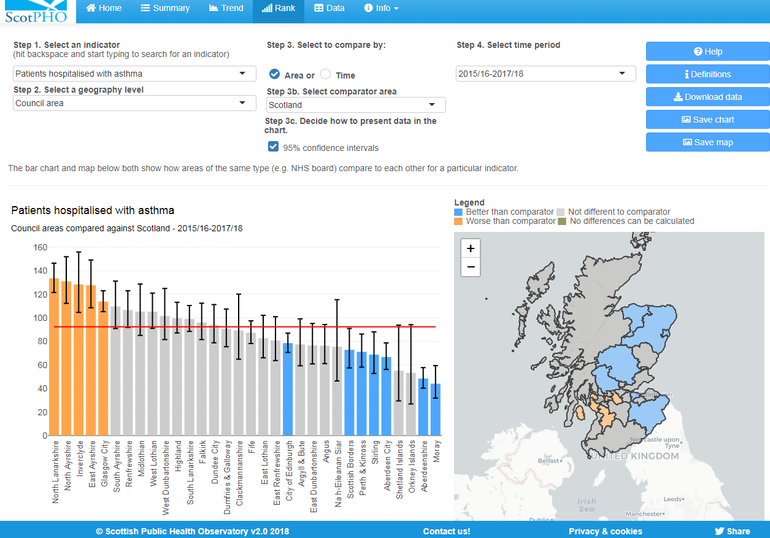Select an indicator at the top left to see the full list of indicators to choose from. Drop-down menus on the left let you choose a type of geography, a time period and a comparison area. The chart bars and regions on the map are coloured to show whether the difference between the area you have selected and the reference area is statistically significant.

Blue buttons on the left allow you to download the data or chart/map image.

By default 95% confidence intervals are hidden but can be added to the chart using the tick box option.

**Use these charts** to show how an indicator varies across areas.

**These charts might help** to identify indicators where an area is comparatively better or worse than others. The chartshows how much variation exists between regions and the map shows geographical patterns.

## **Health inequalities**

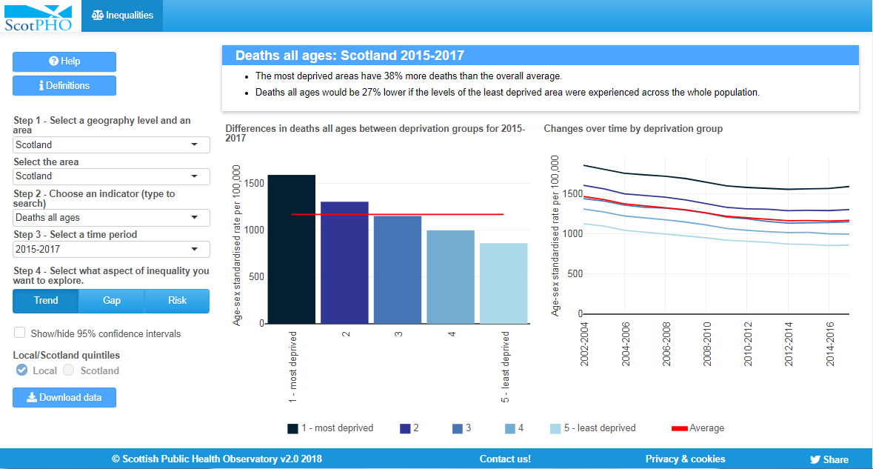ScotPHO are developing a new dashboard to show **health inequalities**.

A range of indicators are presented by local and Scotland SIMD quintile. Initially a limited set of indicators are available but more indicators will be added over time.

Use the option buttons to switch between different measures of inequality

* Rates by SIMD quintile
* SII (slope index of inequality)
* RII (relative index of inequality)
* PAR (population attributable risk)

## **Definitions**

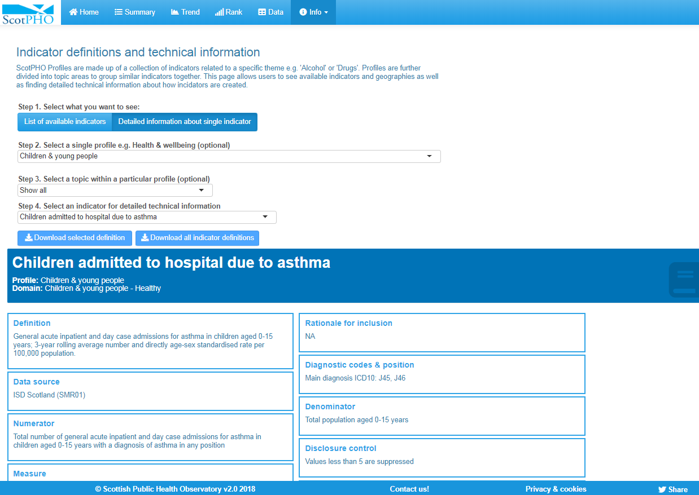Information about the ScotPHO profile indicators is available within the **Definitions** tab.

Use the option buttons to see

* A list of all available indicators, including details of which of the ScotPHO profiles or topic domains they feature in or,
* Detailed information about a single indicator, including data sources, diagnostic codes used.

Filters can be used to select which indicators are available for the topics or areas you are interested in.

Indicator lists or definitions can also be downloaded.

## **evidence for action briefings**

Indicators provide information about the health of an area, but they do not tell you what action can be taken to influence trends in health. The profile tool now includes an initial range of [evidence for action briefings](HTTPS://WWW.SCOTPHO.ORG.UK/COMPARATIVE-HEALTH/PROFILES/RESOURCES/EVIDENCE-FOR-ACTION/), which summarise the best available evidence about what works to influence health in relation to a particular group of indicators. The briefings are available from the Info tab of the new profiles tool. Over time we hope to expand the set of briefings.

## **User tips**

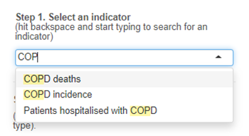Quickly find indicators or areas of interest by clicking on selection filters and typing key words e.g. “COPD” to restriction options.

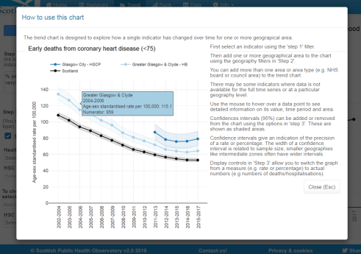

Throughout the app look out for **Help** buttons which contain extra information about how to use and interpret charts.

## **About scotPHO Profiles**

The ScotPHO Profiles present a range of indicators to give an overview of health and its wider determinants at a local level. The profiles provide a snapshot of health for each area and highlight variation through different data visualisations such as rank charts and time trends.

The [**ScotPHO Online Profiles Tool**](https://scotland.shinyapps.io/ScotPHO_profiles_tool/)allows data to be presented at different geographical levels, including health board, council area and where possible, intermediate zone and Health & Social Care Partnership.  The tool also allows comparisons to be made with the Scottish average or another specified area.

**Should you have any issues, questions or comments, please feel free to get in touch with us through** [**scotpho@nhs.net**](mailto:scotpho@nhs.net)