Mortality trends workshop 13th November 2018 – short report

  - Background
Over the past year a number of publications of routine data and academic papers have noted the stalling in gains in life expectancy across the UK. There have also periods of time, such as winter 2014-15, when large, short-term increases in the number of deaths have been observed. A number of agencies and organisations are working within Scotland and across the UK to improve our understanding of these trends through clear description of their nature, and the development and testing of explanatory hypotheses. This workshop was convened in order to take stock of this understanding to date, and to identify next steps, including how agencies can work together to pursue these.
  - Purpose
The aims of the workshop were:
- To share recent work to describe and explain the mortality trends in Scotland and how this relates to international trends.
- To identify hypotheses that might explain the trends.
- To discuss methods of testing the hypotheses.
- To foster collaborative work to test the hypotheses.
  - Format
This was a day long workshop held in Edinburgh. It was attended by 45 participants, the majority of whom work in public health organisations in Scotland, but with representation also from relevant organisations in England, Wales, Northern Ireland, and those with a UK-wide remit.

A number of presentations were given in the morning, outlining descriptive findings to date, and summarising potential hypotheses. These contents of these presentations are summarised in table 1. Over lunchtime there was the opportunity for participants to add to and amend a list of hypotheses. This then formed the basis for work in the afternoon, when small groups convened to discuss the details of some of these hypotheses, and consider how they might be tested.

A list the programme for the day and attendees are provided as an appendices.

Table 1: Summary of presentation contents and reference to relevant slides
No. | Title | Presenter | See slides | Summary of content
1 | UK mortality trends and inequality: changing trends in mortality rates | Chris White (ONS) | 1-41 | -Segmented regression of age-standardised mortality rates in England and Wales to identify breakpoints in the trend.  -Avoidable and amenable mortality trends by area-level deprivation, England and Wales, included assessment of absolute and relative inequalities.  -Health life expectancy trends in England and Wales, and inequalities in HLE.
2 | Scottish mortality trends | Lynda Fenton (Health Scotland) & Julie Ramsay (NRS) | 42-66 | -Average annual increase in life expectancy over time in Scotland, and international comparison  - Segmented regression of age-standardised mortality rates identify breakpoints in the trend.  -Decomposition of changes in life expectancy between 2003-05 and 2009-11 and between 2009-11 and 2015-17 by age group, cause of death and deprivation (SIMD)
3 | Short term fluctuations and long-term trends in recent years | Mike Murphy (LSE) | 67-87 | -What effect does an event such as the 2015 “spike” in the number of deaths have on underlying long-term mortality trends?  -Are short-term and long-term factors independent or linked?  -What role did the 2015 mortality spike have on the persistent change in mortality improvement from around 2011?
4 | English trends | Allan Baker & Justine Fitzpatrick (PHE) | Not available | -Review recent trends in numbers of deaths, mortality rates and life expectancy in England. Focus on differences in trends by specific groups of the population and specific causes of death.
5 | What contribution did influenza make to the excess mortality observed in the winter 2017/18? | Jim McMenamin (HPS) | 88-144 | -Flu surveillance findings  -Real time excess all-cause mortality (EuroMOMO)  -Real time contribution of flu, cold weather and unmeasured confounders to excess all-cause mortality (FluMOMO)  -What is the correlation between respiratory infection and excess all-cause mortality?  -What does data-linkage of NRS, ISD & HPS data show?
6 | The role of austerity, economic downturn and social security | Gerry McCartney (HS) | 145-178 | -Existing literature on components and international patterns of austerity.  -Summary of specific causal pathways that may be included under broad ‘austerity’ heading, and existing evidence for these hypotheses.  -Proposed approach for understanding interactions between hypothesised causes of recent mortality trends.
7 | Summary of hypotheses to explain the recent mortality trends | Gerry McCartney (HS) | 179-189 | Single hypotheses listed under the following overall themes:  Artefactual; Natural limit to lifespan; Migration; Weather; Influenza; Austerity & economic downturn; Obesity; Loneliness & decreased social networks  (see report sections below)
8 | Observational evidence, causal conclusions | Colin Fischbacher (NSS ISD) | 190-205 | Difficulties of drawing causal conclusions from observational evidence  Review of utility of Bradford Hill criteria for this purpose  Alternative approaches: Rothman’s component cause model, Directed Acyclic Graphs

  - Proposed hypotheses to explain recent mortality trends
The summary below briefly presents explanatory hypotheses that were proposed in the course of morning presentations, and supplemented during later discussions:
- Artefact – that observed changes in mortality trends are attributable to measurement artefact. Possible factors include:
  - Effect of the standard population employed to generate directly standardised mortality rates (change in standard population or mismatch between standard and actual population over time).
  - Inaccuracies in denominator population (for example due to returning older people who have been living in EU countries).
  - Combined cohort and inaccurate denominator effects – when cohorts with relatively high mortality move into age bands with less well enumerated denominator (90+ years).

- Attainment of natural limit to lifespan – that gains in life expectancy are slowing as we approach a theoretical maximum

- Austerity and economic downturn – hypotheses were addressed by population group, with examples given below. Overall there is the potential to exert an effect at different levels: for example through individual-level material effects and stress, through effects on social relations, and through effects on the functioning of services.
  - Elderly
    - Reduced or insufficient service provision (especially social care and NHS) and/or changed distribution/accessibility of service leading to increased vulnerability and/or poorer survival in the event of illness
    - Decreased value of Pension Credit
  - Working age and children
    - Reduced value and increased conditionality of social security (including sanctions, change in benefits and problems with how they have been implemented)
    - Lagged effects of unemployment
    - Decreased real value of wages
    - Increased employment precarity, work intensity and reduced sense of control
  - Broader age impacts
    - Homelessness, poorer housing quality
    - Food/fuel insecurity
    - Increased poverty (especially child poverty) and income inequality
    - Increase in state pension age

- Influenza:
  - Virulent strain
  - Size of vulnerable population (may be larger due to lower ‘flu deaths in preceding years)
  - Vaccine-strain mismatch
  - Interactions – vulnerable cohort from historical exposure; austerity/services under strain; austerity/people made vulnerable.

- Loneliness/decreased social networks – particularly among older people

- Migration - in-migration of populations with higher mortality rates

- Obesity – cohort effect population with high-levels of obesity reaching an age at which this is exerting an effect on overall mortality. Obesity was also considered as a factor increasing vulnerability to other potential contributors to mortality trends, such as influenza.

- Weather – effects of cold, snow/ice, heat

  - Interactions between potential explanatory factors
There was recognition with the presentations and discussion that there are likely to be interactions between contributory causal factors. Figure 1 presents a hypothetical example of how these interactions might be considered and presented within a directed acyclic graph.

  - 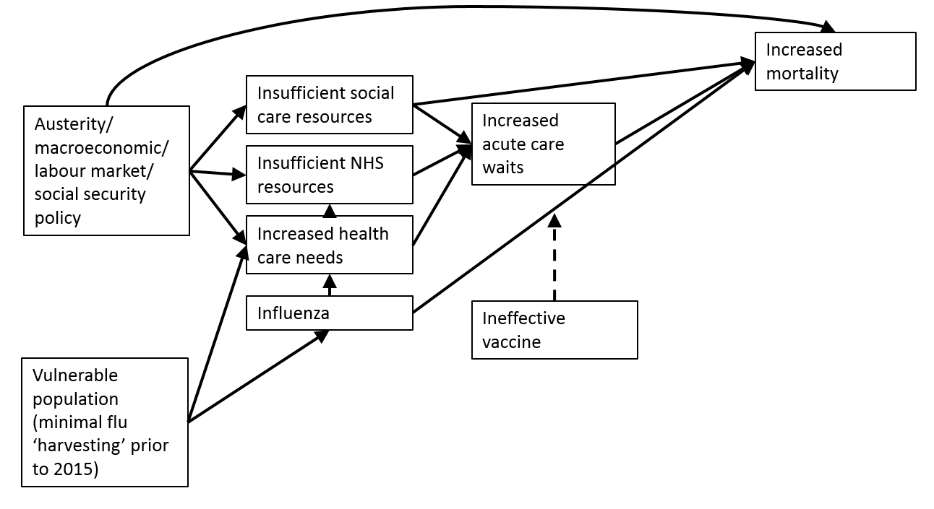
Figure 1: Directed acyclic graph presenting interactions within a hypothetical explanatory model

  - Discussion of hypotheses and approaches to describing and testing them.
Over the course of the afternoon there was the opportunity for smaller groups to discuss particular explanatory hypotheses in more detail. Groups were convened on six broad topics. The topics selected reflected the interests of participants, rather than attempting to exhaustively consider all hypotheses. Key points raised by the groups are summarised in table 2.
Table 2: Key points from group discussions of hypotheses
Topic | Questions considered | Relevant data and analytical approaches
Health and social care | Is capacity-demand mismatch in health and social care a factor in stalled mortality improvements? | -Explore additional mortality measures: amenable, avoidable, premature mortality.  -Possible indicators of system capacity/strain: bed occupancy and number of beds, length of stay, delayed discharges, ED wait (4 hour and long waits), staff absence (holiday and weather effects), deaths in hospital and 30-day mortality, urban-rural differences in service access and resources, social care capacity.
Influenza and seasonal mortality patterns | What contribution does influenza make to:  - high winter mortality?  - overall mortality trends?  What factors are associated with increased mortality due to influenza?  What is the contribution of seasonal variation in deaths, including short-term increases in deaths, to overall mortality trends? | -Effects of strain variation.  -Retrospective application of Euromomo modelling approach over a longer time period to assess sensitivity as a measure of excess mortality.  -Improve ascertainment through data linkage and inclusion of ‘flu in any position on death certificate.  -Explore interactions with austerity through increases in vulnerability and service effects.  -Non-seasonal trends in mortality (background pattern when short-term fluctuations are removed).
Austerity and the economic downturn | What has been the contribution of the economic recession in 2008 and austerity measures implemented since 2010/11 to recent mortality trends? | Considered mechanisms included:  -Health and social care spend (including real-terms changes)  -Housing tenure and housing security  -Employment conditions  -Changes in social security policy and their methods of implementation  -Food and fuel poverty
Artefact | To what extent are recent changes in mortality trends attributable to issues of measurement?  Could recently mortality trends be explained by chance, natural limits to lifespan, or exceptional rapid gains in the preceding time period? | -Effect of changes in standard population used.  -Effect of population ageing.  -Role of denominator inaccuracy.  -Combined cohort and denominator effects (e.g. in 90+ years population)  -International comparison of temporal changes in life expectancy and life span.
Obesity | Is there a population cohort with high prevalence and long duration of obesity that is reaching an age where this is resulting in high mortality and contributing to overall population trends?  What contribution does obesity make to overall population vulnerability, resulting in increased mortality when additional health hazards occur? | -Observational data could be used to explore questions of temporal association, scale, cohort effects, and hence plausible contribution.  -Longitudinal data on trajectories would be required to improve understanding of risks, outcomes and contribution. Some existing sources may provide this e.g. Million Women Study.
Mental health and loneliness | Reductions in mental well-being and mental health are plausibly linked to increasing mortality through multiple causal pathways – how can we describe and assess these? | -Need for longitudinal data on trajectories of mental health and well-being and other health outcomes.  -Need to consider how we conceptualise not only mental ill-health, but also positive health and well-being, to assess effects.  -Consider interaction (in both directions) with other factors e.g. employment, diet, inequality.

  - Next steps
At the workshop there was agreement that it would be appropriate and helpful to collaborate on further work in this area across UK countries and between agencies. There was a commitment to hold a follow-up meeting to assess progress and facilitate coordination, in approximately six months.
Within Scotland a collaborative group for mortality monitoring and analysis has been convened, which will report to the Directors of Public Health. Analytical work is currently being taken forward by Health Scotland, Health Protection Scotland and National Records for Scotland. Those seeking further information on this work, or who wish to contribute should contact Gerry McCartney (gmccartney@nhs.net).
  - Appendix 1: Programme
Mortality trends: workshop
Tuesday November 13th 2018
Grassmarket Centre - 86 Candlemaker Row, Edinburgh, EH1 2QA
The aims of the workshop are:
-To share recent work to describe and explain the mortality trends in Scotland and how this relates to other international trends.
-To identify hypotheses that might explain the trends.
-To discuss methods of testing the hypotheses.
-To foster collaborative work to test the hypotheses.

Programme
09.30 Coffee on arrival
10.00 Welcome and introduction – Gerry McCartney
What are the trends? (Chair – Adele Graham)
10.05 UK trends - Chris White (ONS)
10.30 Scottish mortality trends – Julie Ramsay/Lynda Fenton (NRS/HS)
10.55 Short term fluctuations and long-term trends – Mike Murphy (LSE)
11.20 English trends - Allan Baker/Justine Fitzpatrick (PHE)
Some hypotheses (chair – Colin Fischbacher)
11.45 The role of influenza – Jim McMenamin (HPS)
12.10 The role of austerity, economic downturn and social security – Gerry McCartney (HS)
12.35 - 13.10 Lunch and hypothesis gathering
From hypotheses to a plan (Chair – Gerry McCartney)
13.10 Report back on hypotheses gathered and proposed criteria for evaluation
13.25 Workshop 1a – working on hypotheses in groups to identify supporting, contradicting and missing evidence
Workshop 1b – identifying research methods options to fill evidence gaps
14.25 Break
14.35 Group feedback and discussion:
a. What is the evidence for the hypotheses and what could we test?
b. Interactions and system issues: are we missing anything?
15.45 Plenary discussion - Fostering collaborations and agreeing next steps
16.00 Close

The morning presentations will have 20 minutes each with 5 minutes for questions.
  - Appendix 2: Participants
Syed Ahmed Scottish Government
Julie Arnot ScotPHN
Zsanett Bahor NSS ISD
Allan Baker Public Health England
Jen Bishop Health Protection Scotland
Declan Bradley Public Health Agency (Northern Ireland)
Denise Brown MRC/CSO SPHSU, University of Glasgow
Andrew Carnon NHS Dumfries & Galloway
Julie Cavanagh NHS Tayside
David Chung Royal College of Emergency Medicine
Chik Collins University of the West of Scotland
Simon Cottrell Public Health Wales (Health Protection)
Katie Dee NHS Lothian
Victoria Elliott NHS
Lynda Fenton Health Scotland
Colin Fischbacher NSS ISD
Justine Fitzpatrick Public Health England
John Frank University of Edinburgh
Adele Graham Public Health Agency Belfast
Martin Higgins NHS Lothian
Helene Irvine NHS GG&C
Alastair Leyland University of Glasgow
Pam Maxwell Lead Scotland
Gerry McCartney NHS Health Scotland
Gillian McCartney ScotPHN
Denise McKinlay ScotPHN
Jim McMenamin Health Protection Scotland
Jon Minton NHS Health Scotland
Belinda Morgan NHS Fife
Michael Murphy London School of Economics
Jane Parkinson NHS Health Scotland
Josephine Pravinkumar NHS Lanarkshire
Simon Quirk NHS National Services Scotland
Veena Raleigh The King's Fund
Julie Ramsay National Records of Scotland
Arlene Reynolds Health Protection Scotland
Chris Robertson Strathclyde University
Sophie Sanders Office for National Statistics
Morag Shepherd The Scottish Government
Paul Southworth NHS Health Scotland
David Walsh Glasgow Centre for Population Health
Chris White Office for National Statistics
Neil White Scottish Government
Bruce Whyte Glasgow Centre for Population Health
Grant Wyper NHS Health Scotland

